# Introduction to History

Top of Form

Bottom of Form

The National Security 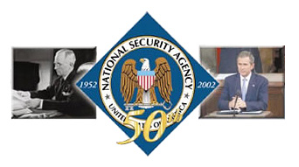Agency was created in November 1952 and has provided timely information to U.S. decision makers and military leaders for more than 50 years. However, even before President Truman signed the memorandum establishing the Agency, pioneer cryptologists laid the groundwork for an organization that would play a critical role in the outcome of all major conflicts. Cryptologist legends such as William and Elizebeth Friedman, Frank Rowlett, Agnes Meyer Driscoll and Herbert O. Yardley are remembered for their brilliant contributions but thousands of other men and women have quietly served their country altering the course of this nation’s history and ensuring a free and safe America. The history of cryptology is their story.

The NSA/CSS boasts a rich heritage and the people who have served their country in any cryptologic capacity understand a legacy unknown to most Americans. From pre-WWI efforts to the most recent conflicts, this nation’s cryptologists have been there quietly protecting and exploiting signals intelligence.

Their efforts and the use of radio intercept, radio direction finding, and processing capabilities gave the United States and its Allies a unique advantage in WWI. The lessons learned here and advances in technology played a critical role in the cryptologic successes in WWII. It was finally realized that cryptanalysts needed to be coordinated under one agency so the Armed Forces Security Agency was formed in 1949. The mission of this newly created agency was to conduct communications intelligence and communications security activities within the National Military Establishment.

However, with its restrictive organizational structure and a lack of a central agency for cryptologic efforts, AFSA could not achieve its mission. It had merely become the military branch for cryptology. The agency was therefore redesigned and all cryptologic activities both military and nonmilitary were brought together to form the National Security Agency.

Since its inception, the Agency has taken responsibility for securing the nation’s communications while exploiting foreign signals intelligence. Although inherently a secret business, a public museum devoted to the history of cryptologists and their work opened to the public in December 1993. Memorabilia ranging from the German Enigma to the recently declassified Cray computer decorate the museum hallways. The National Cryptologic Museum attempts to pull back the veil of secrecy and gives visitors an insight into the history of making and breaking codes. Visitors can get a feel for the legacy and rich heritage that is the cornerstone of the National Security Agency.

# Center for Cryptologic History

Top of Form

Bottom of Form

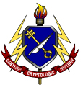The National Security Agency’s Center for Cryptologic History (CCH) preserves and advances understanding of cryptologic history for NSA/CSS, the United States Intelligence Community, the Department of Defense, other government agencies, academia, and the general public. The CCH provides objective, meaningful historical support to Agency leadership and the workforce to enhance decision-making, cryptologic knowledge, and esprit de corps. The CCH also serves as NSA/CSS’s historical outreach to academia and the general public. It produces [unclassified histories](http://www.nsa.gov/history/history_public.cfm) of cryptology that can be obtained. NSA’s Center for Cryptologic History (CCH) sponsors the Symposium on Cryptologic History every two years.

Historians from the CCH and other branches of the U.S. government, as well as distinguished historians from American and foreign academic institutions and veterans of the profession, gather for two days of discussions on this arcane but fascinating subject.

With this year’s theme, “Cryptology and Community,” as a guide, the presenters and guests will consider many of the various communities that perform cryptologic activities and those that are affected by it – the defense and intelligence communities, certainly, but also legal, technical, media, and historical communities, as well as the general public.

Past symposiums have featured path-breaking scholarship and new ways of considering our cryptologic heritage. The mix of practitioners and scholars has always produced spirited exchanges, and in the past this has generated both heat and light. This year’s symposium promises to do the same.

The lunches and refreshment breaks will be held at the conference facilities of the Applied Physics Lab, providing outstanding opportunities to engage in lively discussions and to interact with leading cryptologic historians.

CCH staff consists of professional historians who are veterans of cryptologic operations. CCH can be reached at the address below:

National Security Agency  
Center for Cryptologic History  
Suite 6886  
Fort Meade, MD 20755  
301-688-2336  
[history@nsa.gov](mailto:history@nsa.gov)

# The National Security Agency Insignia

Top of Form

Bottom of Form

In 1965, LTG Marshall S. Carter, USA, Director NSA, directed a device be designed to represent the National Security Agency. The approved insignia is shown here and contains much symbolism.

The white semicircle border displays the words National Security Agency around the top and United States of America around the bottom separated on either side by a five pointed silver star. The shape of the insignia, a circle, represents perpetuity of its continuance, the symbol of eternity.

In a blue field, an American eagle, with wings inverted, is the centerpiece of the device. In heraldry, the eagle is a symbol of courage, supreme power and authority. Use of the eagle in the NSA insignia symbolizes the national scope of the mission of the Agency. The eagle faces its right, the direction of peace (facing left would symbolize war).

The dexter and sinister talons of the bird clutch a silver key. The key in the eagle’s talons, representing the key to security, evolved from the emblem of St. Peter the Apostle and his power to loose and to bind. It also symbolizes the mission to protect and gain access to secrets.

The breast of the eagle boasts a chief blue escutcheon, supported by paleways of thirteen pieces of red and white. The Escutcheon, or Shield, placed on the breast of the eagle is a very ancient mode of bearing. A description of the Escutcheon, taken from that of the Great Seal of the United States, explains that “the escutcheon is composed of the chief and pale, the two most honorable ordinaries (common figures). The pieces, paly, represent the several states all joined in one solid compact entire, supporting a chief, which unites the whole and represents Congress.”

# Image: Picture of the Central Security Service Insignia

# The Central Security Service Insignia

Top of Form

Bottom of Form

In 1996, NSA Director Lt Gen Kenneth A. Minihan, USAF, requested an emblem be created which represented both the National Security Agency and Central Security Service. Although NSA had its own emblem, one had not yet been made for CSS. As a result, the emblem was designed and adopted in that year.

The Intelligence Authorization Act for Fiscal Year 2002, enacted 28 December 2001, amended the National Security Act of 1947 and codified the USCG as part of the Intelligence Community. The new CSS seal was created in September 2002 to reflect the transformations taking place within the Intelligence Community and NSA/CSS, particularly the admission of the United States Coast Guard into the United States Cryptologic System.

The new seal now displays all five of the Service Cryptologic Elements, which are comprised of the United States Naval Security Group, the United States Marine Corps, the United States Army's Intelligence Security Command, the United States Air Forces' Air Intelligence Agency, and the USCG. Each are equally balanced around a five point star on which is centered the symbol of NSA/CSS, who provides the funding, direction, and guidance to all of America's SIGINT activities.

The House of Representatives recognized the USCG's national security objectives in the areas of maritime interception operations, port operations security and defense, military environmental response operations, and peacetime military engagement. The USCG is the only organization responsible for law enforcement, intelligence, and military activities simultaneously. Section 10 of the Authorization added the USCG as an element of the Intelligence Community and placed this organizational element on a par with those of other armed services and agencies.

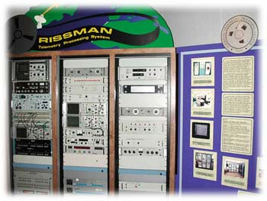***Cray Supercomputers***

Working with companies, such as Cray Research Inc., NSA has been a leader in computer development throughout its history. Some of the earliest supercomputers were designed and built for the National Security Agency.

On exhibit in the museum are two Cray supercomputers. The XMP-24 on display is the upgrade to the original XMP-22 that was the first supercomputer Cray ever delivered to a customer site. It was in operation from 1983 to 1993 and was arguably the most powerful computer in the world when it was delivered. It used serial processing to conduct 420 million operations per second.

The second generation Cray, the YMP, replaced the older version in 1993. It had a 32 gigabyte (32 billion bytes) memory capacity. In 1993 most personal computers held only 16 million bytes. The YMP used vector processing, a very powerful form of overlapping, parallel processing to conduct 2.67 billion operations per second. The YMP was decommissioned and went on display at the museum in 2000.

NSA, with its partners in industry, continues to be a leader in research and development of computer technologies, pioneering the frontiers of computer science and engineering. To house and develop these new systems, NSA has the world's largest supercomputing facility and the Special Processing Lab located on its campus.

**RISSMAN**

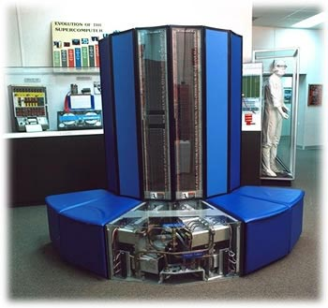RISSMAN was a telemetry processing system, built in the early 1980s featuring custom-designed hardware. As part of NSA's SIGINT mission, telemetry signals were collected by various platforms. Magnetic tape recordings of the intercepted signals were then sent to NSA's National Telemetry Processing Center for processing. These measurements were then sent on computer tape to various analysis centers which identified the function of the various transducers and developed performance estimates. This data was used to formulate defense policy and guide treaty negotiations.

TELLMAN, the Agency's first telemetry processor to make extensive use of a general purpose computer, became operational in 1969. In the early 1980's, TELLMAN was replaced with RISSMAN, which processed a wider variety of signals, with higher system reliability and lower maintenance costs. RISSMAN's custom-designed hardware (still required for the front-end of the signal path) is shown in this exhibit. RISSMAN used three Intel 8086 microcomputers to perform real-time process control, while Digital VAX-11 computers provided data demultiplexing, data file storage, user-interface, Local Area Network access, digital tape generation, and quality-control plotting services. RISSMAN was in daily use, often processing tapes around the clock, from the date of its delivery through the end of the Cold War.